Secure Code Review Summary

# Revision

Version 4

9/8/23 12:27 PM

# SME

Charles Wilson

# Abstract

This document describes the process used to produce a secure code review summary.

# Group / Owner

Security / Secure Software Assessor

# Motivation

This document is motivated by the need to provide security-related feedback during the development of software for use within safety-critical, cyber-physical systems for certification of compliance to standards such as **ISO/SAE 21434** and **ISO 26262**.

# License

This work was created by **Motional** and is licensed under the **Creative Commons Attribution-Share Alike (CC4-SA)** License.

[**https://creativecommons.org/licenses/by/4.0/legalcode**](https://creativecommons.org/licenses/by/4.0/legalcode)

# Overview

Although the quality of feedback from the compiler and static analysis tools have become much better over time with regard to security-related issues, there are many situations which are not considered by them. Secure code reviews provide an opportunity for development to take advantage of the experience of security SMEs to spot problematic usage and provide suggestions as to secure coding best practices.

**Note:** Although the static analysis **[5]**, dynamic analysis **[6]**, and fuzz testing **[7]** activities may be performed in parallel, it is recommended that these activities take place prior to conducting a secure code review.

# Process

## Secure Code Review

|  |  |
| --- | --- |
| **Inputs** | Element |
| **Outputs** | Identified issues  Secure code review summary |
| **Participants** | Security SME  Development SME |

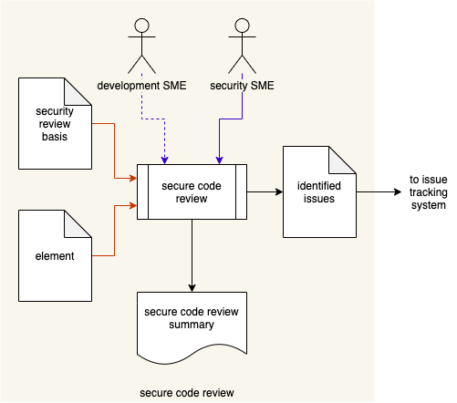

The Security SME, possibly with input from the Development SME, review the **Element** with respect to how it implements its security-relevant aspects (**Security Review Basis**). The composition of the **Security Review Basis** is described in the **Secure Development** AVCDL secondary document. Issues identified during the review are tagged in the code review system and entered into the issue tracking system. A **Secure Code Review Summary** is generated.

# References

1. **Design Showing Security Considerations** (AVCDL secondary document)
2. **Product-level Security Requirements** (AVCDL secondary document)
3. **Secure Settings Document** (AVCDL secondary document)
4. **Currently Used Deprecated Functions** (AVCDL secondary document)
5. **Static Analysis Report** (AVCDL secondary document)
6. **Dynamic Analysis Report** (AVCDL secondary document)
7. **Fuzz Testing Report** (AVCDL secondary document)
8. **Secure Design** (AVCDL secondary document)
9. **SEI CERT Coding Standards**[**https://wiki.sei.cmu.edu/confluence/display/seccode/SEI+CERT+Coding+Standards**](https://wiki.sei.cmu.edu/confluence/display/seccode/SEI+CERT+Coding+Standards)
10. **MISRA**[**https://www.misra.org.uk**](https://www.misra.org.uk)
11. **C++ Core Guidelines**[**https://isocpp.github.io/CppCoreGuidelines/CppCoreGuidelines**](https://isocpp.github.io/CppCoreGuidelines/CppCoreGuidelines)
12. **Secure Coding Guidelines for Developers**[**https://docs.oracle.com/cd/E26502_01/html/E29016/scode-1.html**](https://docs.oracle.com/cd/E26502_01/html/E29016/scode-1.html)
13. **NIST SP 800-78-4 Cryptographic Algorithms and Key Sizes for Personal Identify Verification**[**https://csrc.nist.gov/publications/detail/sp/800-78/4/final**](https://csrc.nist.gov/publications/detail/sp/800-78/4/final)
14. **NIST SP 800-131A Transitioning the Use of Cryptographic Algorithms and Key Lengths**[**https://csrc.nist.gov/publications/detail/sp/800-131a/rev-2/final**](https://csrc.nist.gov/publications/detail/sp/800-131a/rev-2/final)
15. **AUTOSAR Guidelines for the use of the C++14 language in critical and safety-related systems**[**https://www.autosar.org/fileadmin/user_upload/standards/adaptive/18-10/AUTOSAR_RS_CPP14Guidelines.pdf**](https://www.autosar.org/fileadmin/user_upload/standards/adaptive/18-10/AUTOSAR_RS_CPP14Guidelines.pdf)
16. **Writing Secure Code, 2ed**[**https://www.amazon.com/dp/0735617228**](https://www.amazon.com/dp/0735617228)
17. **BSIMM – Code Review**[**https://www.bsimm.com/framework/software-security-development-lifecycle/code-review.html**](https://www.bsimm.com/framework/software-security-development-lifecycle/code-review.html)